**Positional Analysis**

Positioning is the process of determining what positions an individual has in a social network (group or community). In social network analysis, there are certain strategies/tools we use to determine how individuals are positioned. This includes but not limited centralization, inbound (indegree) versus outbound (outdegree) connections and other similar measures. In positional analysis, nodes are grouped based on the similarity in their pattern of connection.

The positions can be seen as roles as in social settings, individuals in similar positions tend to perform similar functions/tasks within the network thus having a similar connection pattern. However, this is not always the case.

The data used in this analysis is extracted from the directed advice network for the midterm project. For the simplicity of the plot, self-loop are omitted as it’s more meaningful to focus on the direction of information flow. Given that positional analysis is based on identifying structurally equivalent nodes, there is a more generalized notion of structural equivalence.

The nodes are considered to share a position or role when they have generally similar patterns of relations, rather than exact ones i.e. the nodes don’t have to connect to the exact same node but should share a similar structure. For example, a teacher who connects to 4 students and a principal is structurally equivalent to another teacher who also connects to 4 students and the principal even if they do not connect to the exact same students. There are many strategies for identifying roles in the networks which include, Brokerage Typology, Structural Equivalence, Isomorphic Local Graphs, Block Modeling with CONCOR, and Stochastic block modeling. A more cohesive and supportive advice network is generated with the name and position generator.

**Baseline Network Plot**

In order to have a visual representation to distinguish the departments, the network is plotted as a graph.

Fig 1.0 Baseline (original)

Fig 1.1 Baseline (Randomized) A picture containing purple, lavender

Description automatically generated

**Algorithm 1. Brokerage**

To measure brokerage roles, the Gould-Fernandez measure is used. This method uses the department attribute to measure brokerage roles.

The sample output is shown below.

Based on the output for the original data, node 'a1' has no incoming or outgoing ties and is not involved in any brokerage relationships. Therefore, it does not fill any of the mentioned roles (Coordinator, Itinerant Broker/Consultant, Representative, Gatekeeper, or Liaison). It serves as a standalone node within the network, in our case, the CEO of the company.

Node 'a2' has no coordination brokerage ties weighted by advice, 1 itinerant brokerage tie, initiated no gatekeeper brokerage ties, 3 representative brokerage ties and 2 liason brokerage ties. This individual is involved in 6 brokerage ties in total.

Fig 2.0 Brokerage (Original)

Node 'a3' on the other hand, has no coordination brokerage ties weighted by advice, 1 itinerant brokerage tie, initiated no gatekeeper brokerage ties, no representative brokerage ties and 9 liason brokerage ties. This individual is involved in 10 brokerage ties in total.

For the randomized data, Node 'a10' has no coordination brokerage ties weighted by advice, 1 itinerant brokerage tie, initiated no gatekeeper brokerage ties, no representative brokerage ties and 10 liason brokerage ties. This individual involved in 11 brokerage ties in total

Fig 2.1 Brokerage (Randomized)

Node 'a11' on the other hand, has no coordination brokerage ties weighted by advice, 2 itinerant brokerage ties, initiated no gatekeeper brokerage ties, no representative brokerage ties and 17 liason brokerage ties. This individual involved in 10 brokerage ties in total. The output provides insights into the brokerage roles and positions within the random network, shedding light on the patterns interdepartmental connections and the influence of specific nodes in facilitating the flow of communication and collaboration within and between departments.

The other nodes can be explained in a similar manner by considering their respective values for `w_I`, `w_O`, `b_IO`, `b_OI`, `b_O`, and `t`. We can utilize these nodes to gain a clearer understanding of the specific roles and positions that each node fulfills within the network.

**Algorithm 2. Structural Equivalence**

In the concept of structural equivalence, two nodes are considered structurally equivalent when they share identical relationship patterns with all other nodes in the network. This can be assessed by comparing the sets and patterns of neighbors for each node or by calculating the absolute difference between the row values of a matrix which represents the relationships of the two nodes. When the absolute difference between nodes is 0, those nodes are considered to be structurally equivalent. By examining these criteria, we can determine whether two nodes exhibit structurally equivalent properties in the network.

For example, for nodes ‘a1’ and ‘a2’, the sum of their absolute differences is 18, This means that they are not structurally equivalent. Fig 3.0 Structural Equivalence

For the randomized data, the sum of the absolute differences of nodes a1 and a2 is 5. They are not structurally equivalent but are perceived to be more similar than in the original data.

Fig 3.1 Structural Equivalence

By extrapolating every pair of nodes in the advice network then convert into a similarity matrix, sets of similar actors are identified using K-Means Clustering algorithm. The following plots show the actors who are proximately similar when set the number of clusters equal to 4 and 5.

Fig 3.3 Cluster of 5

Fig 3.2 Clusters of 4

The output of the randomized data is below:

Fig 3.4 Clusters of 4 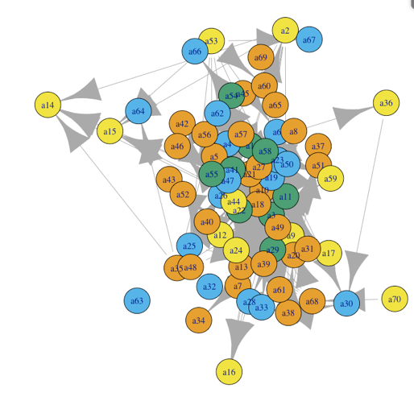

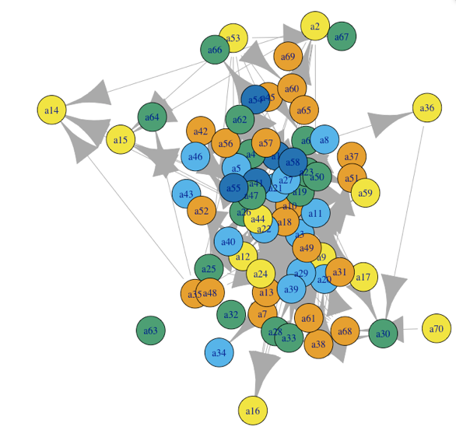

Fig 3.5 Clusters of 5

Note: Recall that a2 represents an executive member of the sunglass company grouped together as occupying the same positions as the employees when set the number of clusters equals to 5 in the original data The reason for this phenomenon is that there is a strict definition of structural equivalence which relies on comparing the precise set of actors that each node is connected to. As a result, this method confuses similarity with closeness. This means that some nodes that we deem structurally inequivalent may be regarded as similar in actuality. On the other hand, the cluster of 4 makes more logical sense as it groups most executive and management members into the same clusters.

**Algorithm 3. Block Modeling with CONCOR**

The CONCOR algorithm operates on the basis of a similar concept of equivalence as described in structural equivalence. This strategy identifies structurally equivalent nodes based on the patterns in their connections or relationships. In addition to that, CONCOR takes advantage of correlation and stacks matrices which is used to create a block model that incorporates multiple relationships at the same time.

Based on the output, there are some entry and medium-level employees are classified as the same as those in the executive groups.

page4image39980224

The main aim of the CONCOR strategy is converging the data to only -1s and 1s. This is done by repeatedly running correlation on the results of the initial correlation, the data will eventually converge to only -1s and 1s.

Fig 4.0 Original data output

Fig 4.1 Randomized output

The output of the final blocks is 4 clusters as shown below.

Fig 4.2 Original Data Output (Final Blocks)

Fig 4.3 Randomized data output (Final Blocks)

This is then plotted and the nodes are colored by positions. Based on the output, there are some entry and medium-level employees are classified as the same as those in the executive groups.

Fig 4.5 Original Data Output

Fig 4.6 Randomized Data Output

**Algorithm 4. Isomorphic Local Graphs**

To identify the individuals who are precise structural equivalent, isomorphic is used. This method works by relaxing the condition that requires the nodes be tied to precisely the same set of nodes by defining them as structurally equivalent as long as their local neighborhoods are automorphic. The underlying algorithm, bliss, essentially permutes the matrices of the two networks it is comparing to see if, under any of the different permutations, the two matrices are equivalent. Isomorphic local graph analysis tries to identify similar sub-graphs within a network (For example, the cliques within a school). These subgraphs are smaller sections of the network that exhibit identical structural characteristics.

The neighborhood size was set to 3 and 4, and looped through the different local neighborhoods to evaluate whether they are automorphic, the output plot shows nodes who share isomorphic neighborhoods. Using 4 clustering which seems to be more logical.

Fig 4.7.1 Neighborhood size = 3 Fig 4.7.2 Neighborhood size = 4

** Fig 4.8.1 Neighborhood size = 3 Fig 4.8.2 Neighborhood size = 4

**Algorithm 5. Stochastic Block Models**

In an Stochastic block modeling, the network is divided into a predefined number of blocks. Each node is assigned to one of the blocks. The main objective of this is to uncover the underlying block structure and the connections between them. The connections within a block are typically denser compared to connections between blocks. Instead of being dependents on the individuals that share the same set of nodes, the individuals who share a role or position will have the same probability of being attached to all other alters in the network. With the use of this method, equivalence is not absolute, but based on probability.

Fig 5.0 Stochastic Block Model (Original)

Fig 5.1 Randomized data output

Based on the output of true (original) scenarios, it can be concluded that the community structure captured by the model accurately represents the underlying social dynamics in the advice network.